Авторизация и регистрация пользователей
(реализовано через окна Window)
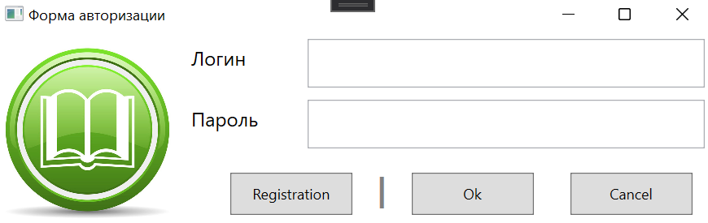
XAML
<Window x:Class="TestApp.AuthorizationWindow"
xmlns="http://schemas.microsoft.com/winfx/2006/xaml/presentation"
xmlns:x="http://schemas.microsoft.com/winfx/2006/xaml"
xmlns:d="http://schemas.microsoft.com/expression/blend/2008"
xmlns:mc="http://schemas.openxmlformats.org/markup-compatibility/2006"
xmlns:local="clr-namespace:TestApp"
mc:Ignorable="d"
Title="Форма авторизации" Height="200" Width="600" MinHeight="200" MinWidth="600">
<Grid x:Name="MainGrid">
<Grid.ColumnDefinitions>
<ColumnDefinition Width="150"/>
<ColumnDefinition/>
</Grid.ColumnDefinitions>
<Image Source="/Pictures/Lib2.jpg" Grid.Column="0"/>
<StackPanel Grid.Column="1">
<Grid >
<Grid.ColumnDefinitions>
<ColumnDefinition Width="100"/>
<ColumnDefinition/>
</Grid.ColumnDefinitions>
<Grid.RowDefinitions>
<RowDefinition Height="50"/>
<RowDefinition Height="50"/>
<RowDefinition Height="*"/>
</Grid.RowDefinitions>
<Label Content="Логин" Margin="5,5,0,0" FontSize="16" Grid.Column="0" Grid.Row="0"/>
<TextBox x:Name="LoginText" Margin="5,5,5,5" Grid.Column="1" Grid.Row="0" VerticalContentAlignment="Center" Padding="5,0,0,0"/>
<Label Content="Пароль" Margin="5,5,0,0" FontSize="16" Grid.Column="0" Grid.Row="1"/>
<TextBox x:Name="PasswordText" Margin="5,5,5,5" Grid.Column="1" Grid.Row="1" VerticalContentAlignment="Center"/>
<StackPanel Grid.Column="0" Grid.Row="3" Grid.ColumnSpan="2" Orientation="Horizontal" HorizontalAlignment="Right">
<Button x:Name="RegistrationButton" Content="Registration" Height="35" Width="100" Margin="15,15,15,0"
Click="RegistrationButton_Click"/>
<Label Content="|" FontSize="26" FontWeight="Bold" VerticalContentAlignment="Bottom" Foreground="Gray"/>
<Button x:Name="AuthorizationCommit" Content="Ok" Height="35" Width="100" Margin="15,15,15,0"
Click="AuthorizationCommit_Click"/>
<Button x:Name="AuthorizationRollBack" Content="Cancel" Height="35" Width="100" Margin="15,15,15,0"
Click="AuthorizationRollBack_Click"/>
</StackPanel>

</Grid>
</StackPanel>
</Grid>
</Window>
CS
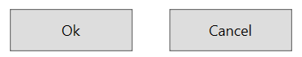
private Base.LibraryExEntities DataBase;

public AuthorizationWindow()
{
InitializeComponent();
try
{
DataBase = new Base.LibraryExEntities();
}
catch
{
MessageBox.Show("Не удалось подключиться к базе данных. Проверьте настройки подключения приложения.",
"Предупреждение", MessageBoxButton.OK, MessageBoxImage.Warning);
Close();
}

private void AuthorizationCommit_Click(object sender, RoutedEventArgs e)
{
Base.Users User = DataBase.Users.SingleOrDefault(U => U.Login == LoginText.Text && U.Password == PasswordText.Text);
if (User != null) {
MainWindow window = new MainWindow();
window.Show();
Close();
}
else {
MessageBox.Show("Неверно указан логин и/или пароль!", "Предупреждение", MessageBoxButton.OK, MessageBoxImage.Warning);
};
}

private void AuthorizationRollBack_Click(object sender, RoutedEventArgs e)
{
if (MessageBox.Show("Вы действительно хотите выйти из программы?", "Внимание", MessageBoxButton.OKCancel, MessageBoxImage.Warning) == MessageBoxResult.OK)
{
Close();
}
}
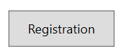
private void RegistrationButton_Click(object sender, RoutedEventArgs e)
{
RegistrationWindow window = new RegistrationWindow(DataBase);
window.ShowDialog();
}
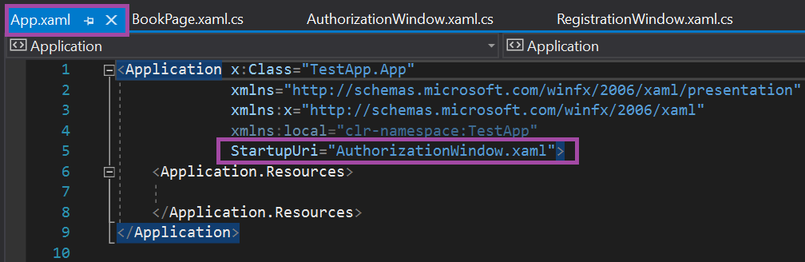
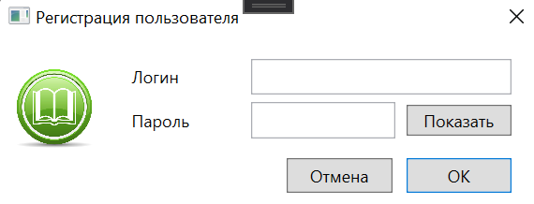
XAML
<Window x:Class="TestApp.RegistrationWindow"
xmlns="http://schemas.microsoft.com/winfx/2006/xaml/presentation"
xmlns:x="http://schemas.microsoft.com/winfx/2006/xaml"
xmlns:d="http://schemas.microsoft.com/expression/blend/2008"
xmlns:mc="http://schemas.openxmlformats.org/markup-compatibility/2006"
xmlns:local="clr-namespace:TestApp"
mc:Ignorable="d"
Title="Регистрация пользователя" Height="160" Width="400"
ResizeMode="NoResize"
WindowStartupLocation="CenterScreen">
<Grid>
<DockPanel>
<StackPanel DockPanel.Dock="Left">
<Image DockPanel.Dock="Left" Width="60" Height="60"
Margin="10,20" Source="Pictures/Lib2.jpg"/>
</StackPanel>

<StackPanel Margin="10,15,20,0">
<DockPanel >
<Label Content="Логин" Width="90"/>
<TextBox x:Name="LoginTextBox" TabIndex="0"/>
</DockPanel>

<DockPanel Margin="0,5,0,0">
<Label Content="Пароль" Width="90"/>
<Button x:Name="PasswordButton" DockPanel.Dock="Right"
Content="Показать" Width="75" Margin="8,2,0,2" TabIndex="1"
Click="PasswordButton_Click"/>
<TextBox x:Name="PasswordTextBox" Width="0" Visibility="Hidden"
TabIndex="1"/>
<PasswordBox x:Name="PasswordPasswordBox" TabIndex="2"/>
</DockPanel>

<DockPanel Height="25" Margin="0,14,0,0" LastChildFill="False" >
<Button x:Name="OkButton" Content="ОК" Width="75"
DockPanel.Dock="Right" TabIndex="3" IsDefault="True"
Click="OkButton_Click"/>
<Button x:Name="CancelButton" Content="Отмена" Width="75"
DockPanel.Dock="Right" Margin="0,0,10,0" TabIndex="4"
IsCancel="True" Click="CancelButton_Click"/>
</DockPanel>
</StackPanel>
</DockPanel>
</Grid>
</Window>
CS
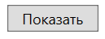
private void PasswordButton_Click(object sender, RoutedEventArgs e)
{
// Переброска необходимой информации во временные буферы
String Password = PasswordPasswordBox.Password;
Visibility Visibility = PasswordPasswordBox.Visibility;
double Width = PasswordPasswordBox.ActualWidth;
// Изменение подписи на кнопке
PasswordButton.Content = Visibility == Visibility.Visible ? "Скрыть" : "Показать";
// Переброска информации из TextBox'а в PasswordBox
PasswordPasswordBox.Password = PasswordTextBox.Text;
PasswordPasswordBox.Visibility = PasswordTextBox.Visibility;
PasswordPasswordBox.Width = PasswordTextBox.Width;
// Возврат информации из временных буферов в TextBox
PasswordTextBox.Text = Password;
PasswordTextBox.Visibility = Visibility;
PasswordTextBox.Width = Width;
}
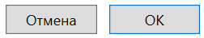
public partial class RegistrationWindow : Window
{
// Контекст бызы данных
private Base.LibraryExEntities Database;

public RegistrationWindow(Base.LibraryExEntities Database)
{
InitializeComponent();
this.Database = Database;
}
……
private void OkButton_Click(object sender, RoutedEventArgs e)
{
// Создание и инициализация нового пользователя системы
Base.Users User = new Base.Users();
User.Login = LoginTextBox.Text;
User.Password = PasswordPasswordBox.Password != "" ? PasswordPasswordBox.Password : PasswordTextBox.Text;
User.IdRole = 0;
User.FriendlyName = "";
// Добавление его в базу данных
Database.Users.Add(User);
// Сохранение изменений
Database.SaveChanges();
Close();
}

private void CancelButton_Click(object sender, RoutedEventArgs e)
{
Close();
}

